DAY 4: Evening Assessment

1. Create a list of 5 integers and print them.



2. Create a list of strings and print each element using a for loop.

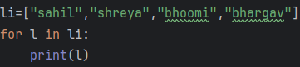

3. Find the length of a given list using len().



4. Access the 2nd and 4th elements from a list.

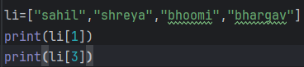

5. Create a list of numbers and print a sublist from index 1 to 3.

output: [2, 3, 4]

6. Add a new element at the end of a list using append().

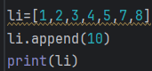output: [1, 2, 3, 4, 5, 7, 8, 10]

7. Insert an element at the 2nd position using insert().

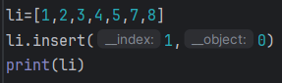output: [1, 0, 2, 3, 4, 5, 7, 8]

8. Add multiple elements to a list using extend().

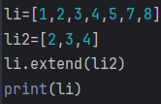

9. Remove a specific element from a list using remove().

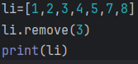

10. Remove the last element of a list using pop().

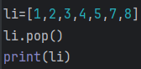output: 1,2,3,4,5,7

11. Sort a list of numbers in ascending order using sort().

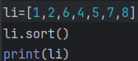 output:1,2,4,5,6,7,8

12. Reverse a list using reverse().

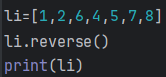output: 8,7,5,4,6,2,1

13. Count how many times a specific element appears in a list using count().

output: 4

14. Find the index of an element using index().

output: 9

15. Copy a list into another list using copy().

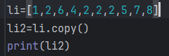output: [1, 2, 6, 4, 2, 2, 2, 5, 7, 8]

16. Clear all elements from a list using clear().

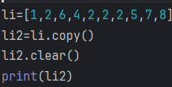output: []

17. Use list comprehension to create a list of squares from 1 to 10.

output: [1, 4, 9, 16, 25, 36, 49, 64, 81, 100]

18. Create a nested list (list inside a list) and access an element from the inner list.

output: 2

19. Check if a particular element exists in a list using the 'in' operator.

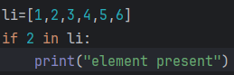output: element present

20. Write a program to take 5 numbers from the user, store them in a list, and print the sum of all numbers.

